Hyperparameter set 1

training_args = Seq2SeqTrainingArguments(
output_dir="./results_mod_batch",
evaluation_strategy="epoch",
save_strategy="epoch",
load_best_model_at_end=True,
per_device_train_batch_size=8,
per_device_eval_batch_size=8,
gradient_accumulation_steps=2, # Effective batch size = 16
num_train_epochs=4, # Capped at 4 epochs
learning_rate=2.5e-5, # Moderated LR for stable convergence
weight_decay=0.1, # Same as previous moderate config
warmup_ratio=0.05, # Ratio-based warmup
predict_with_generate=True,
fp16=True,
logging_dir="./logs_mod_batch",
logging_strategy="epoch",
report_to=["tensorboard"],
label_smoothing_factor=0.07, # Balanced smoothing
)

{'rouge1': 0.06799797704727062, 'rouge2': 0.010392989508805378, 'rougeL': 0.06773651592810578, 'rougeLsum': 0.06756962709925989}
Evaluation Metrics (Fine-Tuned Model): {'BLEU': 0.017672960319474882, 'ROUGE-1': 0.06799797704727062, 'ROUGE-2': 0.010392989508805378, 'ROUGE-L': 0.06773651592810578, 'METEOR': 0.10929249096983246}

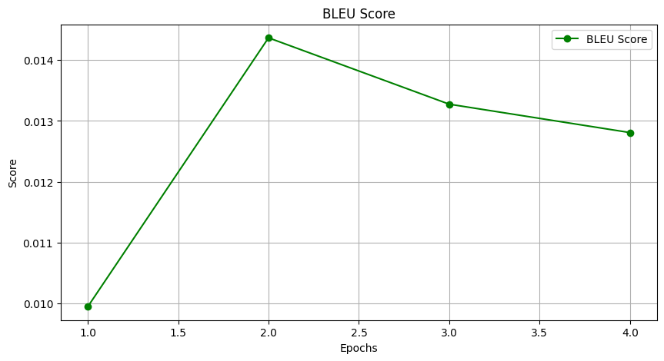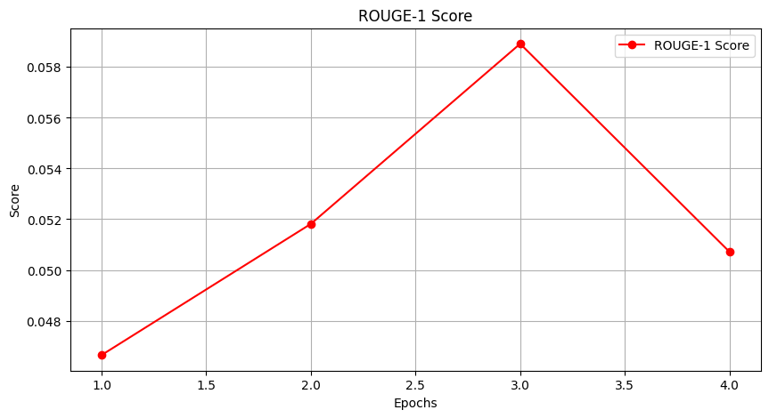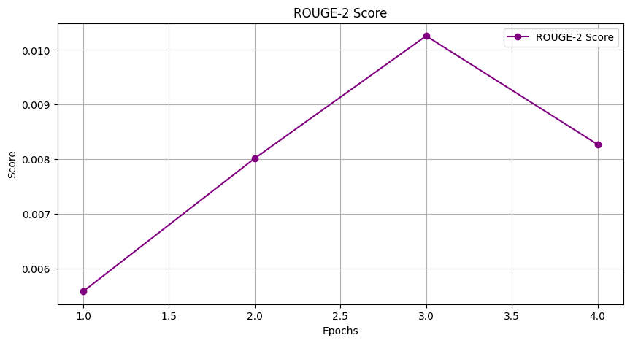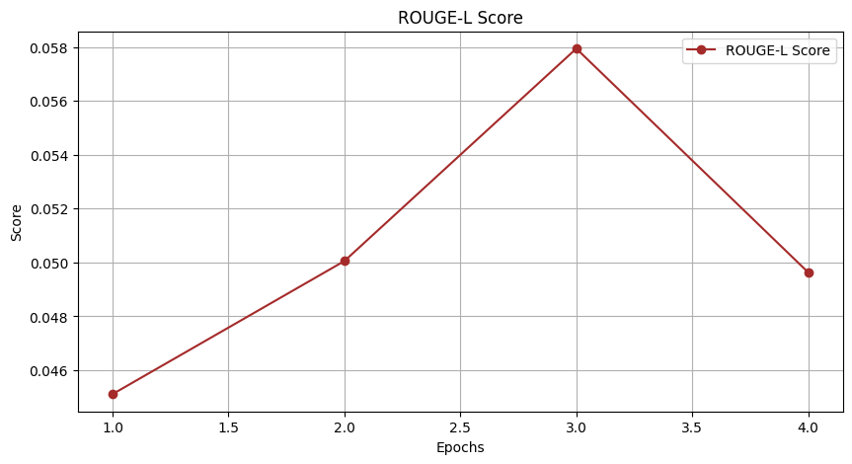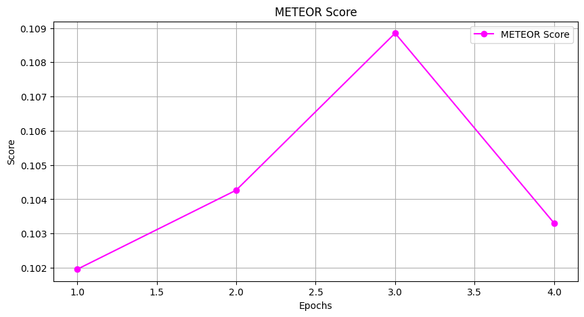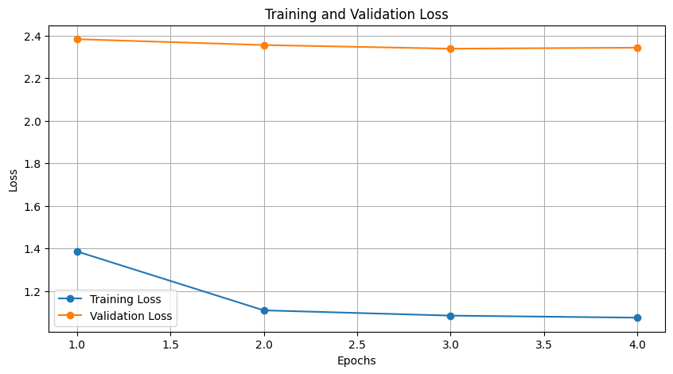
__________________________________________________________________________

Hyperparameter set 2

training_args = Seq2SeqTrainingArguments(
output_dir="./results_large_batch",
evaluation_strategy="epoch",
save_strategy="epoch",
load_best_model_at_end=True,
per_device_train_batch_size=16, # Larger batch size
per_device_eval_batch_size=16,
gradient_accumulation_steps=1, # No accumulation needed
num_train_epochs=4, # Capped at 4 epochs
learning_rate=2e-5, # Slightly lower LR for larger batch stability
weight_decay=0.05, # Lower weight decay to avoid underfitting
warmup_ratio=0.06, # Ratio-based warmup
predict_with_generate=True,
fp16=True,
logging_dir="./logs_large_batch",
logging_strategy="epoch",
report_to=["tensorboard"],
label_smoothing_factor=0.08, # Moderately regularized
)

{'rouge1': 0.07341671314547261, 'rouge2': 0.01229201741325689, 'rougeL': 0.07326554910320368, 'rougeLsum': 0.07290212225393716}
Evaluation Metrics (Fine-Tuned Model): {'BLEU': 0.016691677272882153, 'ROUGE-1': 0.07341671314547261, 'ROUGE-2': 0.01229201741325689, 'ROUGE-L': 0.07326554910320368, 'METEOR': 0.10801830553140529
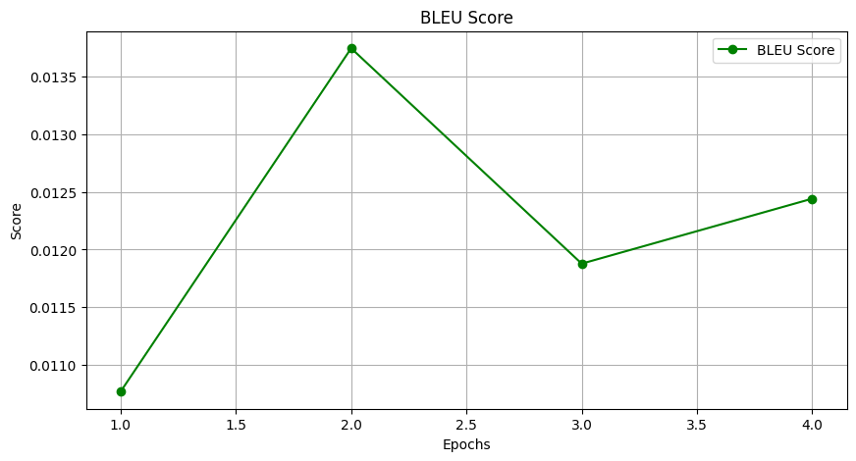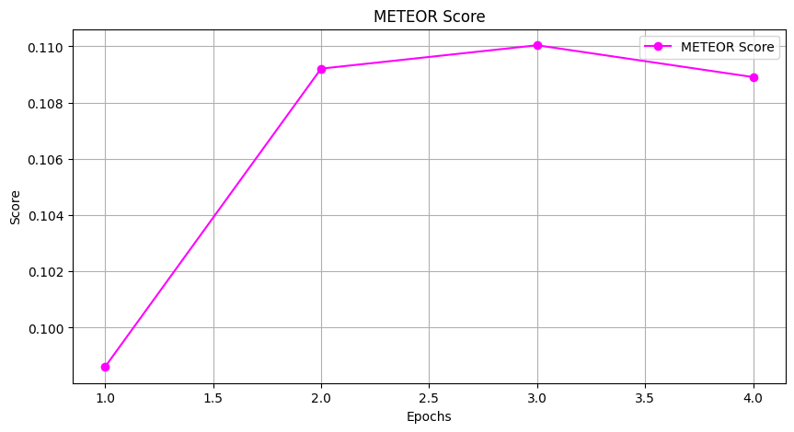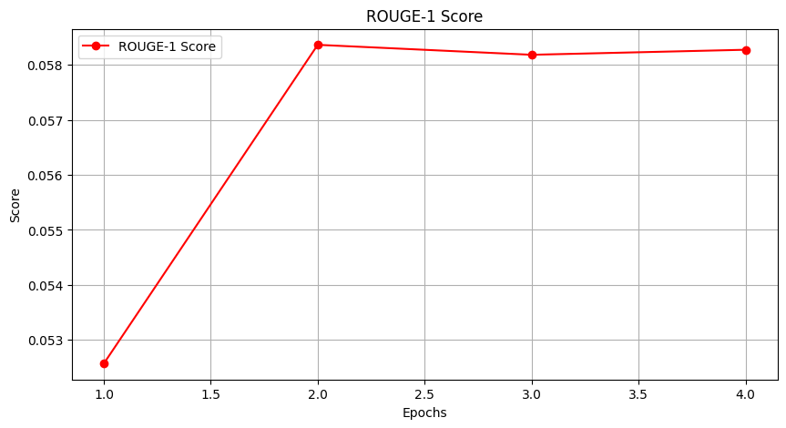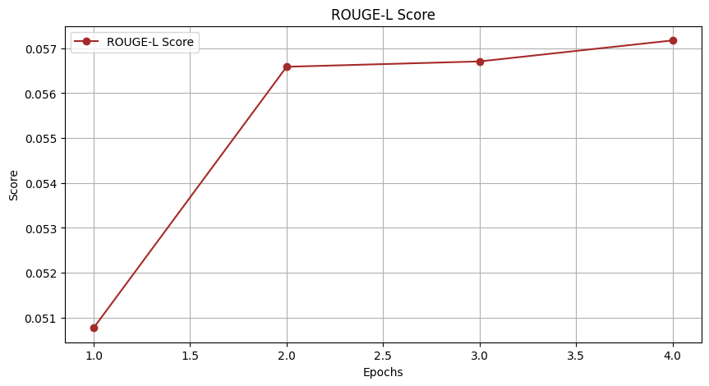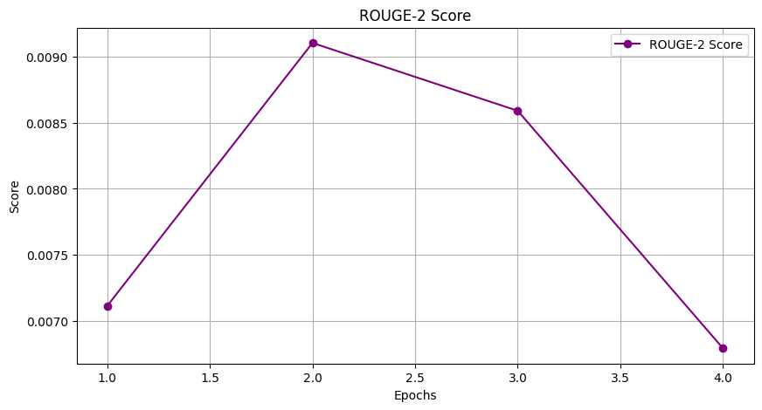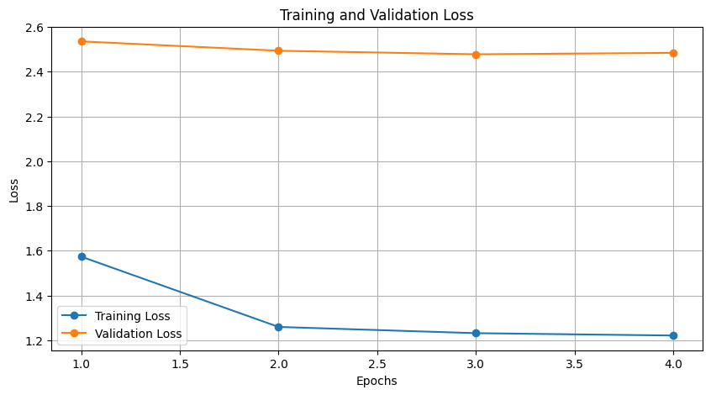

______________________________________________________________________

Hyperparameter set 3

training_args = Seq2SeqTrainingArguments(
output_dir="./results",
evaluation_strategy="epoch",
save_strategy="epoch",
load_best_model_at_end=True,
per_device_train_batch_size=8,
per_device_eval_batch_size=8,
num_train_epochs=4, # Increased epochs for more gradual learning
learning_rate=3e-5, # Lower learning rate for more stable updates
weight_decay=0.1, # Slightly increased weight decay to help reduce overfitting
warmup_steps=1000, # Added warmup steps for a gradual ramp-up of learning rate
predict_with_generate=True,
fp16=True,
logging_dir="./logs",
logging_strategy="epoch",
report_to=["tensorboard"],
label_smoothing_factor=0.1 # Added label smoothing to help reduce overconfidence and overfitting
)
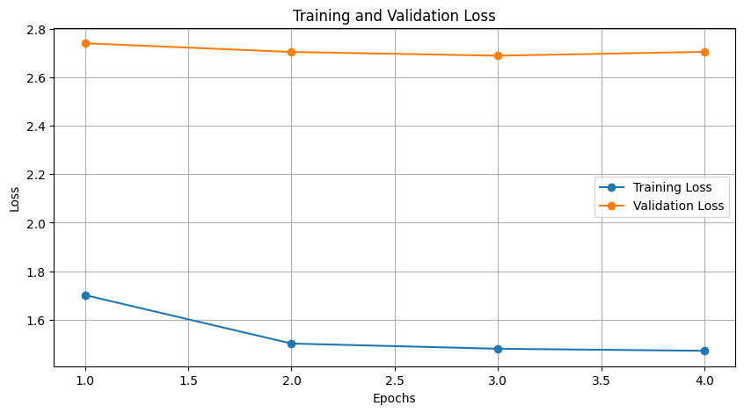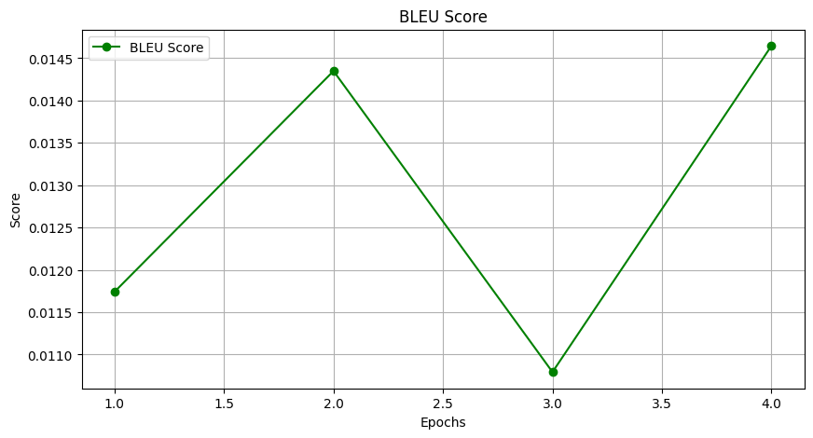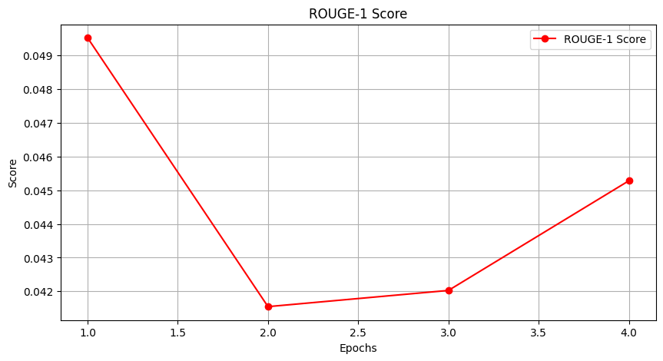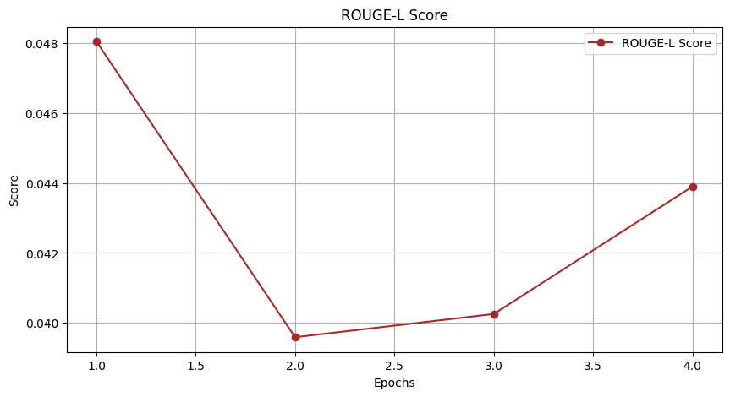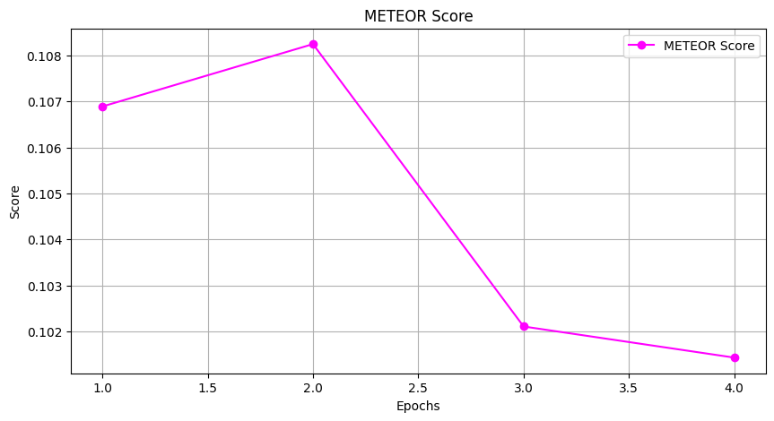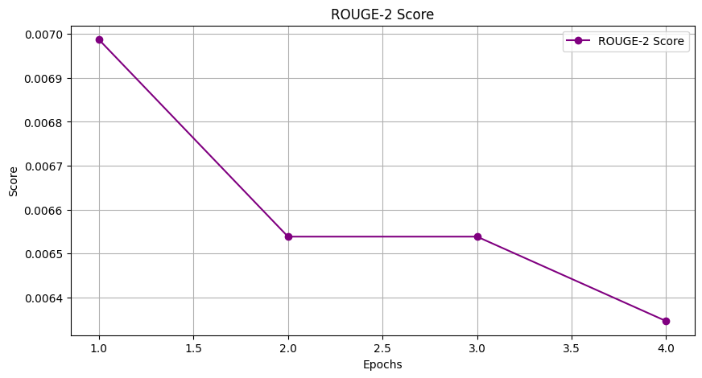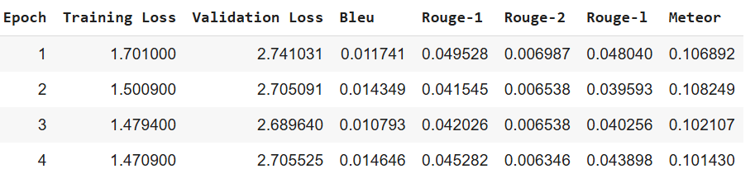
{'rouge1': 0.05446781592993254, 'rouge2': 0.008397830612101243, 'rougeL': 0.053592722332356645, 'rougeLsum': 0.05322241416598271}
Evaluation Metrics (Fine-Tuned Model): {'BLEU': 0.015863846867241016, 'ROUGE-1': 0.05446781592993254, 'ROUGE-2': 0.008397830612101243, 'ROUGE-L': 0.053592722332356645, 'METEOR': 0.10164826742393684}

